Definition of AI
“AI is the study of how to make computers do things which, at the moment, people do better.” (Rich)
“AI is the part of computer science concerned with designing intelligent computer systems, that is, systems that exhibit characteristics we associate with intelligent human behavior.
  - understanding language, reasoning, solving problems, and so on.”
“AI is the study of ideas which enable computers to do things which make people seem intelligent.”
AI is the study of intelligence using the ideas and methods of computation.”
“A bridge between art and science”
“Tesler’s Theorem: AI is whatever hasn’t been done yet.”
“AI is a field of science and engineering concerned with the computational understanding of what is commonly called intelligent behavior, and with the creation of artifacts that exhibit such behavior.”
AI may be defined as the branch of computer science that is concerned with automation of intelligent behavior.
Artificial Intelligence as Science
Understand and working of the mind in mechanistic terms, just as medical
science seeks to understand the working of the body in mechanistic
terms.
Understand intelligent thought processes, including perception, motor control, communication using human languages, reasoning, planning, learning, and memory.
AI as Engineering
How can we make computer based systems more intelligent?
In practical terms, intelligence means
  - 1. Ability to automatically perform tasks that currently require human operators.
  - 2. More autonomy in computer systems; less requirement for human intervention or monitoring.
  - 3. Flexibility in dealing with variability in the environment in an appropriate manner.
  - 4. Systems that are easier to use: able to understand what the user wants from limited instructions.
  - 5. Systems that can improve their performance by learning from experience.
AI technique
A method that exploits knowledge that should be represented in such a way that:
  - the knowledge captures generalizations.
  - It can be understood by people who must provide it.
  - It can easily be modified.
  - It can be used in a great many situations.
  - It can be used to help to narrow the range of possibilities
Criteria for Success
Turing Test
  - Can we make the machine thinks like a human?
  - Assume that you ask questions and you don’t know if you are talking to a human or a machine.
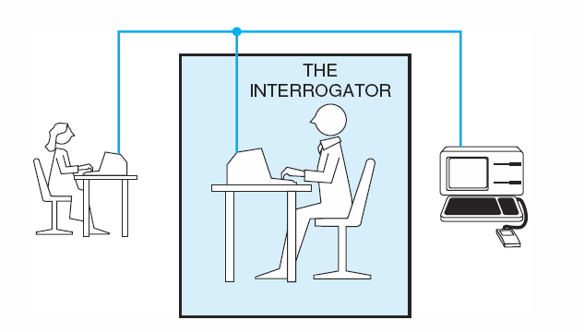
AI Application Areas
- Two fundamental AI research areas
  - Knowledge Representation: represent the computer’s knowledge of the world by some kind of data structures in the machine’s memory
  - Search: a problem-solving technique that systematically explores a space of problem states
- Game Playing
- Automated Reasoning and Theorem Proving
- Expert Systems
- Natural Language Understanding and Semantic Modeling
- Modeling Human Performance
- Planning and Robotics
- Machine Learning
- Neural Nets and Genetic Algorithms
Game Playing
Games are good vehicles for AI research because
  - most games are played using a well-defined set of rules
  - board configurations are easily represented on a computer
Games can generate extremely large search spaces.
  - Search spaces are large and complex enough to require powerful techniques(heuristics) for determining what alternatives to explore in the problem space.
Automated Reasoning and Theorem Proving
- Automatic Theorem Proving is the oldest branch of AI.
  - Theorem proving research was responsible for much of the early work in formalizing search algorithms and developing formal representation languages such as predicate calculus and logic programming language PROLOG.
- Variety of problems can be attacked by representing the problem description and relevant background information as logical axioms and treating problem instances as theorems to be proved.
- Reasoning based in formal mathematical logic is also important.
  - Many problems such as the design and verification of logic circuits, verification of the correctness of computer programs, and control of complex systems require automated reasoning.

Problems in AI
1.Example: Romania
Problem: On holiday in Romania; currently in Arad.
Flight leaves tomorrow from Bucharest. Find a short
route to drive to Bucharest.

Formulate problem:
states: various cities
actions: drive between cities
solution: sequence of cities, e.g., Arad, Sibiu,
Fagaras, Bucharest
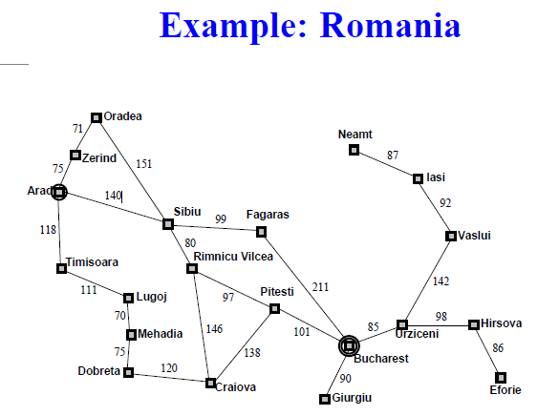

2.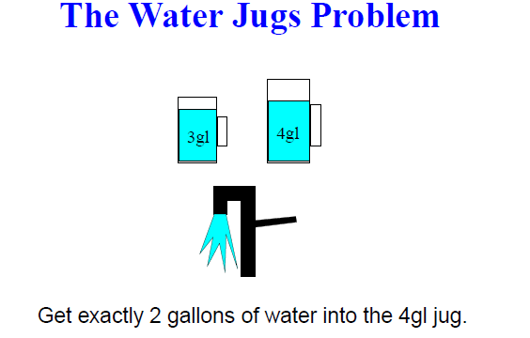
The Water Jugs Problem: Operators
